http://www.dell.com/support/manuals/us/en/19/dell-supportassist-openmanage-essentials-v2.1/saomeug-v5/setting-supportassist-to-maintenance-mode?guid=guid-4a97a6d8-682d-4170-b474-3146acb57fab&lang=en-us

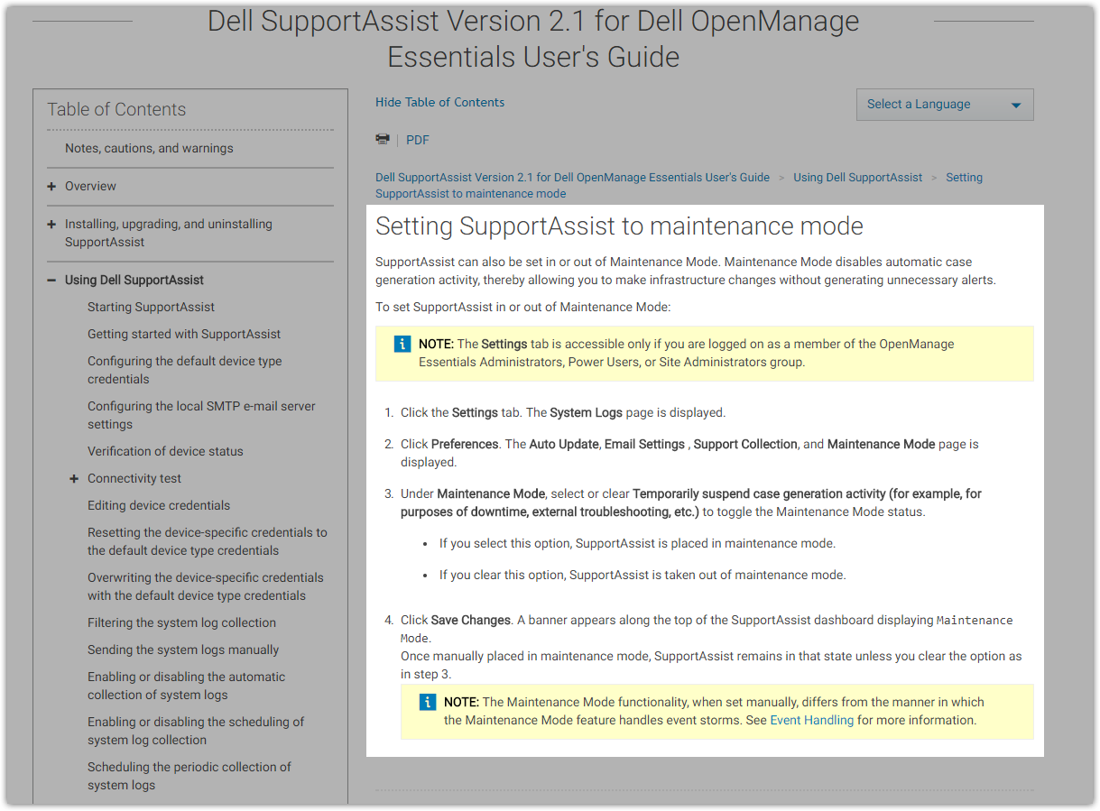

#
# To turn off “Maintenance Mode” it needs to be unchecked follow checkbox.
